“Book Nook”
Project Proposal
1. Overview I plan to build an application called "Book Nook." The main problem I want to solve is how easily readers lose track of books they want to read or forget titles they have already finished. My motivation is to create a clean, distraction-free tool that lets users search for books and manage their own personal library without the clutter of social media features.
2. Target Audience I am designing this for students, casual readers, and book club members. It will serve anyone who needs a quick way to look up book details and maintain a simple "To Read" list on their phone or laptop.
3. Major Functions
- Search for Books: Users can type a title or author to find books using the Open Library database.
- View Search Results: The app will display a grid of book covers with titles and authors.
- See Book Details: Clicking a book reveals more info like page count, publisher, and year.
- Add to Wishlist: Users can click a button to save a book to their specific "To Read" list.
- Mark as Read: Users can move a book from the Wishlist to a "History" list to track what they have finished.
- Remove Books: There will be a delete button to remove items from lists if the user changes their mind.
- Sort Library: Users can sort their saved lists alphabetically to find specific titles faster.
- Save Data: The app will use LocalStorage so the user's lists are still there when they refresh the page.
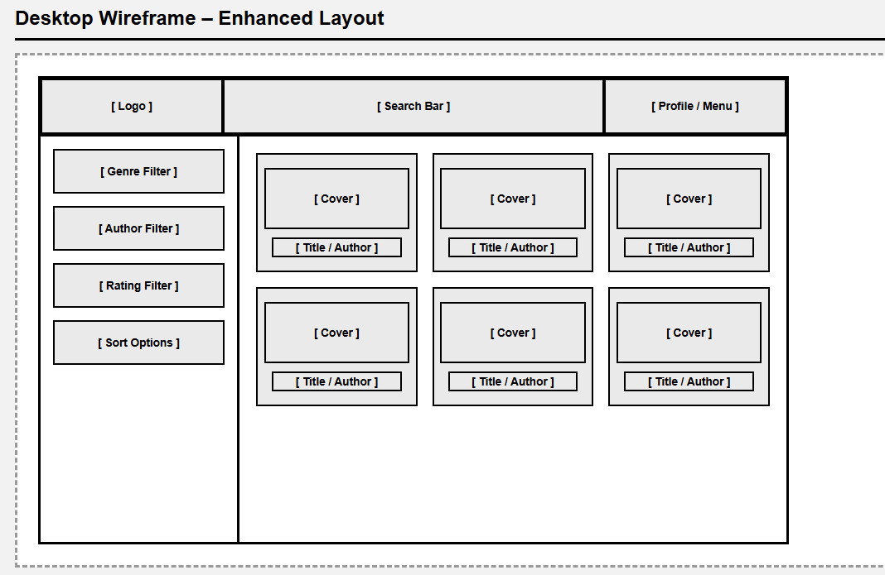
4. Wireframes.
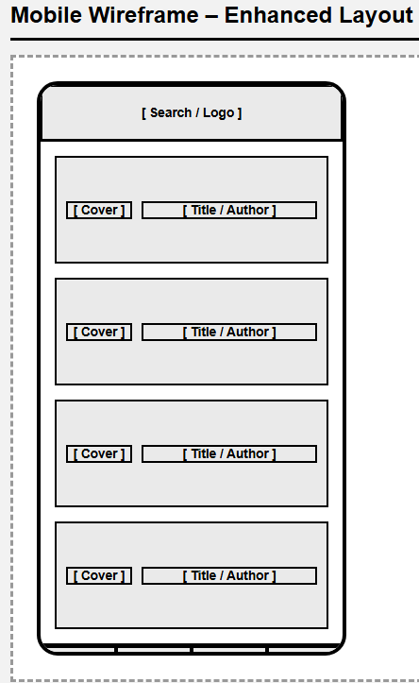
5. External Data Sources I will use the Open Library Search API (openlibrary.org/search.json). This API is robust and provides well over the required attributes, including Title, Author, Cover ID, Publish Year, ISBN, Publisher, Language, and Page Count.
6. Initial Module List I will organize the code into standard web files: index.html for structure, styles.css for design, main.js for event listeners, api.js for fetching data, storage.js for handling LocalStorage, and render.js for updating the DOM.
7. Graphic Identity My color scheme will use a "Cozy Library" theme with a Warm Beige background, Dark Brown text, and Sage Green accents. I will use the "Merriweather" serif font for headings to mimic book print and "Open Sans" for body text. The icon will be a simple vector of an open book.
8. Schedule
- Week 5: I will set up the project files and build the api.js module to successfully fetch and log data from the API. I also plan to finish the basic HTML structure and search view.
- Week 6: I will build the render.js module to make the book cards look good and implement storage.js so users can save items to LocalStorage.
- Week 7: I will finish the "Mark as Read" and sort functions, refine the CSS for mobile screens, and do final bug testing.
(https://trello.com/invite/b/695b47f2d56fb12a2b0aad54/ATTIc2b12f037b6c4f24c078bba6cb03a235D8DB1F9A/sleep-outside-team-11)
9. Project Planning
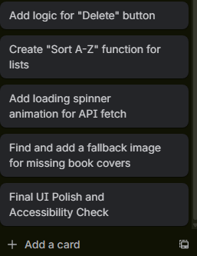
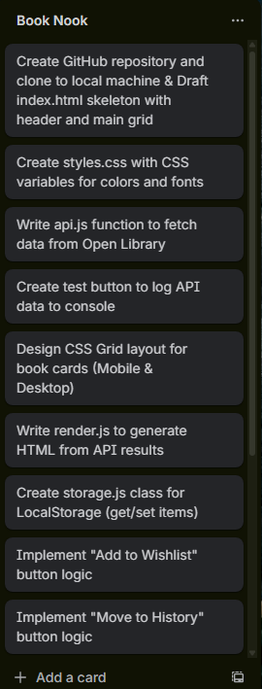

10. Challenges I anticipate the biggest challenge will be handling books that don't have cover images in the API, which means I'll need a solid fallback image. I also think managing the async code to show a loading state while the API searches might be tricky.

